Ownership Structure Declaration

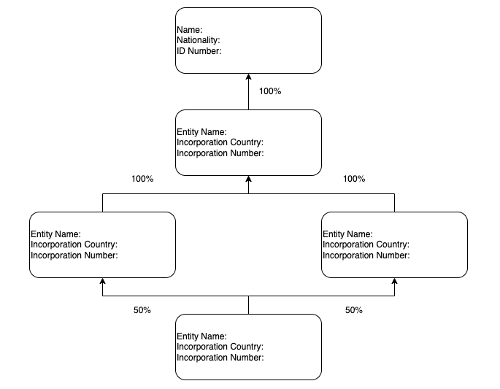
[Please replace this sample image with your entity’s ownership structure including the Entity Name, Incorporation Country, Incorporation Number and Shareholding % of EACH Intermediary Layer]

I confirm there is no other individual owning 25% or more of the shares or voting rights and the above structure is accurate and up-to-date.

____________________________
(Director Signature)
Name:
Date:

